***Project:*** Google drive security

***Platform:*** web

***product overview:*** A software which encrypts and decrypts files on a google drive and authenticates the user via face recognition.

***Requirements:***

1. *Login:*

• Google authorized login

Priority: Low

2. *Face verification:*

• verifies user

• takes an initial picture and uses it

• Will verify face every time phone screen is turned off

• Anti-spoofing Accuracy High

Priority: High

3. *Encryption:*

• Added files through the app will be encrypted and then saved on the drive

• Files will be .DOC and .PDF

Priority: Medium

4. *Decryption:*

• When selecting a file from the drive through the app, the file will be decrypted

• A temp decrypted file will be made

• Temp file will be deleted when the tab is closed/user logs out/user face mismatch or absent

• Temp file will be deleted when the app is closed

Priority: Medium

***UML Use Case:***

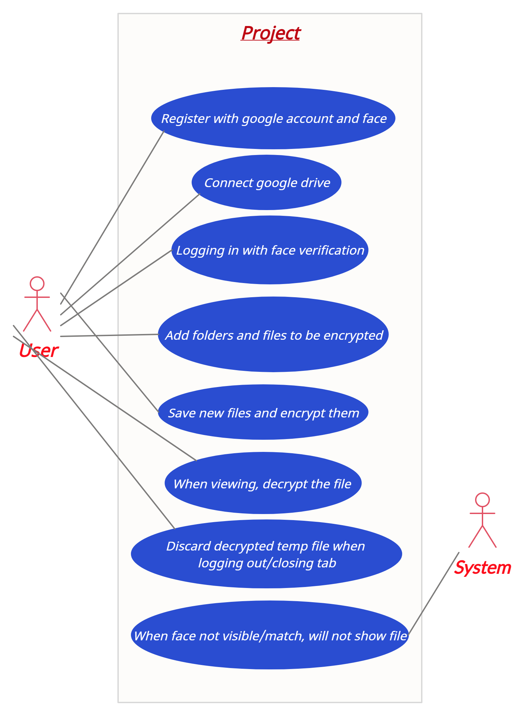

***5 Week plan:***

*Week 1: I*mplementation of encryption feature

*Week 2:* Constructing the decryption and login functions

*Week 3:* Face recognition, authentication

*Week 4:* Anti spoofing

*Week 5:* Design and improvements